A Year in Review
  - July 2018 – July 2019

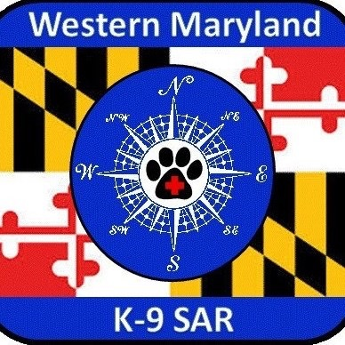

Table of Contents

Mission Statement……………………………………………………1
Our Organization………………………………………………………2
Search and Rescue Missions……………………………………3
Community Events………………………………………………… 4
Team Members Certifications………………………………..5

mission Statement

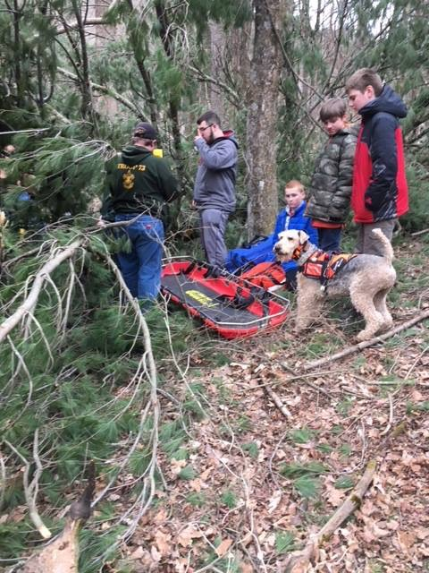

Western Maryland K-9 Search and Rescue (WMSAR) is a non-profit community based organization created for the purpose of providing trained and capable K-9 teams and supporting ground search teams to search for missing or lost persons. WMSAR specializes in wilderness search and rescue missions and operations and training. We also present educational programs to the community and public safety professionals concerning basic survival when lost and the efficient use of K-9 search and Rescue Teams.

1
Our Organization and its Accomplishments
We feel that success of a Search and Rescue Organization can be measured by its ability to provide qualified, well equipped field team members to assist in searches 24 hours a day, 365 days a year. Although we are a small team, during the last year years we have met this standard by 100%. As a result of this dedication we have been recognized as a Task Force Member with the Maryland Department of Natural Resources.
In 2017, 35% of our team members were nationally certified. We increased this number to 60% in 2018. It is our goal to increase this number to 70% in the next two years, keeping in mind that we are always in the process of training new members and therefore it is unlikely the team will ever have 100% of its members certified at any one time. In 2017, 20% of our K-9’s were nationally certified. We increased that number to 50% in 2019. Our goal is to increase this number to 80% in the next two years.
We have also achieved a strong working bond with law enforcement agencies. The teams work closely together during search and rescue operations and creating a strong working bond before the need arises is priceless during an emergency. These agencies include: Pennsylvania Department of Conservation and Natural Resources (DCNR), Bureau of State Parks Michaux State Forest park and forest rangers; Maryland State Police officers and local law enforcement agencies including Frederick City Police and Frederick County Sheriff’s Office; West Virginia State Police officers and local law enforcement agencies. As we continue to build on current relationships with public safety, new relationships arise not only with public safety, but throughout the community as well. We have been invited to provide K-9 demonstrations at National Night Out, assisted local Boy Scouts in earning their Search and Rescue Badge, and provided K-9 teams to support the Make-A –Wish Foundation during their 26 mile Wilderness Trail Challenge.

2

Search and Rescue Missions 7/2018-7/2019
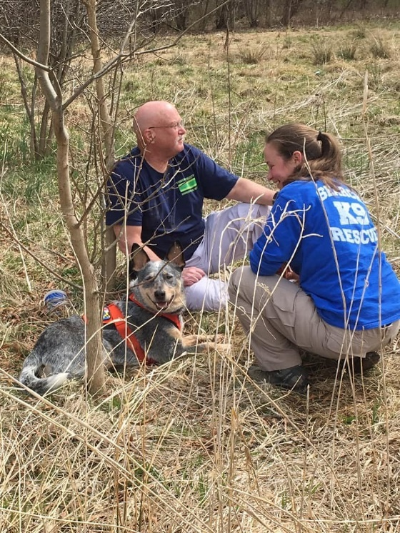
Date Location Notes
8/19/2018 Mt. Airy, MD Standby for Search
6/18/2018 Mechanicsburg, PA Multi-agency Search
(subject located)
5/27/2019 Hamburg, PA Standby for Search
5/16/2019 West Virginia Multi-agency Search
subject located)
5/5/2019 Mercersburg, PA Multi-agency multi-day search
(subject located)
4/25/2019 Rouzerville, Pa Multi-agency Search
(subject located)
10/19/2019 Western Md. Multi-agency Search
(subject located)
10/4/2019 Glen Burnie, MD Multi-agency Search
(subject located)
4/21/2018 Michaux St. Forest, PA Multi-agency Search
(subject located)

3

Community Events 7/2018-7/2019

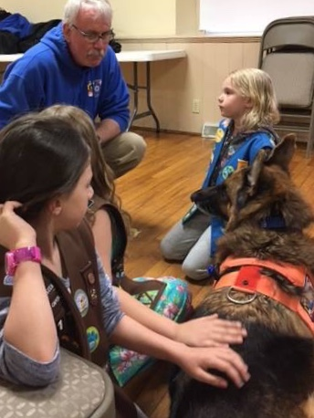

Dates Community Organization and Focus

8/7/2018 National Night Out, Carroll Valley Borough Police Dept.
(Safety education and K-9 Demo)
10/20/2018 Urbana Fire Dept. Open House
(K-9’s meet children, talk about outdoor safety)
11/13/2018 Boy Scouts, Carlisle PA
(Presentation on Search and Rescue, meet K-9’s)
3/19/2019 Boy Scout Camporee, Walkersville, MD
(Assist BS in earning Search and Rescue Badge)
4/19/2019 University of Maryland @ Baltimore
(Provided K-9 teams to participate in field practicum for
Search Manager Course)
6/1/2019 Make-a-Wish Foundation Trail Challenge
(Provided support by having K9 teams on site and ready
to deploy in the event that a participant became lost
during 26 mile wilderness hike)

4

Team Members Certification Level Other Relevant Certification/Courses

Stacy Watts SARTECH 2.STM CPR/1st Aid/AED, ICS: 100, 200, 700, 800,
MD Search Team Member, Wilderness 1st Aid

H. Bill Blackwelder SARTECH 2 CPR/1st Aid/AED , ICS: 100, 200, 700 800
Wilderness 1st Responder, Swift Water Rescue,
Advanced Swift Water Rescue, EMT
(Assistant Team Leader)

Claudia Weakland K-9 SARTECH 2 CPR/1st Aid/AED, ICS: 100, 200, 700, 800, Lost Person Behavior,
OSHA, Bloodborne Path, Canine 1st Aid, Registered Nurse

Ann Frank K-9 SARTECH 2/STM CPR/1st Aid/AED, ICS: 100, 200, 700, 800
MD Search Team Member
Bloodborne Path. WFR-Wilderness, LVT, CVT, RVT
Fear Free Vet Visit Advisory Board

Chris Carroll SARTECH 1 CPR/1st Aid/AED, ICS: 100, 200, 300, 700, 800, 809, OSHA, (Team Leader) National SAR School-Inland SAR Planning, Basic Inland SAR
SARTECH 1 & 2 Evaluator, Blood borne pathogens,
ACA Canoe & Kayak Instructor
Gary Rodgers SARTECH 2/STM CPR/1st Aid/AED, ICS: 100, 200, 700, 800
MD Search Team Member, Wilderness 1st Aid

Melanie Currie SARTECH 2 ICS: 100, 200, 700, 800, CPR/1st Aid, MD Search Team Member
Wilderness1st Aid

Dave Smith SARTECH 2/STM ICS: 100, 200, 700, CPR/1st Aid, Wilderness 1st Aid Instructor

Dave Power K-9 SARTECH 2 ICS: 100, 200, 700, 800 CPR/1st Aid, Bloodborne Path.
Canine 1st aid, SARTECH 2 and K-9 SARTECH evaluator

Alyssa Vance STM ICS: 100, 200, 700, 800 CPR/1st Aid, EMT/Paramedic
Patrick Coffee Trainee

5

